Writing Homework

Correlations and Reliability
Follow APA manual to describe your results. Integrate your answers to the following questions into ONE paragraph, as you would see in a journal article. Follow the APA Format Checklist at the bottom of this assignment. Use APA-style abbreviations (including italics!) and parentheses where appropriate. Use active voice.

- How many participants did you have? Describe them by year in school (how many participants at each year).
- Describe the average number of countries visited by students of different years, noting any outliers and discussing whether they appear to be error or interesting outliers (and why).
- Report and interpret the correlation between number of countries visited and height. Explain in plain language what this correlation means, using principles from class.
- Assess the reliability of the conscientiousness scale. Identify which type of reliability you can appropriately calculate from the data you have, report the coefficient you obtained, and interpret the meaning and acceptability of that coefficient.
- Interpret the correlations you calculated among conscientiousness, neatness, and number of countries visited. As before, explain in plain language what each correlation means, using principles from class.
- Finally, provide one table in APA style that summarizes the descriptive statistics and correlations among conscientiousness, neatness, and number of countries visited. Follow the examples given in lecture and the APA Tables Examples documents to format your table properly – you should be able to do all of this in one table.
Follow the example structure below;
Table X
Descriptive Statistics
 |  |  | Correlations
 | M | SD | 1 | 2 | 3
Variable 1 | X.XX | X.XX | --
Variable 2 | X.XX | X.XX | .XX | --
Variable 3 | X.XX | X.XX | .XX | .XX | --

Note. If you want to add a note, do it here.
For the writing;
As you have no information about the significance of any of these correlations or differences at this point, “significance” should not form any part of your discussion.
APA Checklist for Your Paragraph:
- Use active voice – no zombies. (whatever you do, don’t say “the analyses were run”).
- Use first person language.
- Use numerals instead of writing out numbers (except at the beginning of a sentence).
- Report decimals to 2 places.
- Include zeros before decimal values that can be greater than 1.0, and not before values that cannot be greater than 1.0.
- Don’t capitalize names of analyses, statistics, variables, or conditions.
- Use APA statistical abbreviations: M, SD, r, appropriately capitalized, for your statistics.
  - Put abbreviations in italics.
  - Don’t use abbreviations when you’ve already used the word in the same sentence.
  - To use the α symbol, in MS Word, go to the “Insert” menu and then choose “Symbol.” You can find α under the “Greek and Coptic” category.
- If you choose to put some of your values in parentheses, remember that the rest of the sentence must stand on its own (make grammatical sense) if you skip over the parentheses. Try reading it aloud.
APA Checklist for Your Table:
- Label your table as a table (Table 1).
- Put your variables in rows and different kinds of values in columns.
- Group information logically.
- Remember that a correlation table is symmetric – you only need to report the lower triangle.
- Use horizontal rules between major sections.
- Use white space – not vertical lines – to separate columns.
- Do not use colors or shading
- Use APA statistical abbreviations (with appropriate capitalization and italics) where they are relevant.
- Report numbers to 2 decimal places.
- Include zeros before decimal values that can be greater than 1.0, and not before values that cannot be greater than 1.0.

To write the one paragraph, it helps to use the answers below.
1/ Which class (sophomore, junior, or senior) has the largest number of students interested in forensic psychology?
More expressed interest in forensic psychology than any other group, with students in this year choosing this as their top interest area.
2/ What is the mean number of countries visited by students in each year (sophomore, junior, senior, other)? Report the numbers here (rounding to two decimals).
Sophomores:
Juniors:
Seniors:
3/ Create a pirate plot to represent the data in your answer above. Attach your plot here.
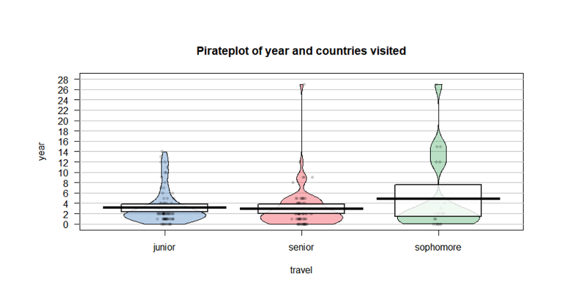
4/ What information do you learn from the pirate plot that you didn’t get just from the means? Be specific and talk about this data in particular, not just pirate plots in general.
- Raw data,
The graph above pictorially describes the raw data which cannot be seen using the mean above, that is, we can see the extreme values and how the data points( travel) are distributed across the year.
- Descriptive statistics,
The graph gives detailed information about mean, median and mode, and interquartile range as shown by the rectangular figures, the dark lines shows the means, while the upper corner shows the 75% quartile while the lower corner shows the 25% quartile.
5/ Does number of countries visited appear to be associated with height? Create a scatterplot and attach it here.
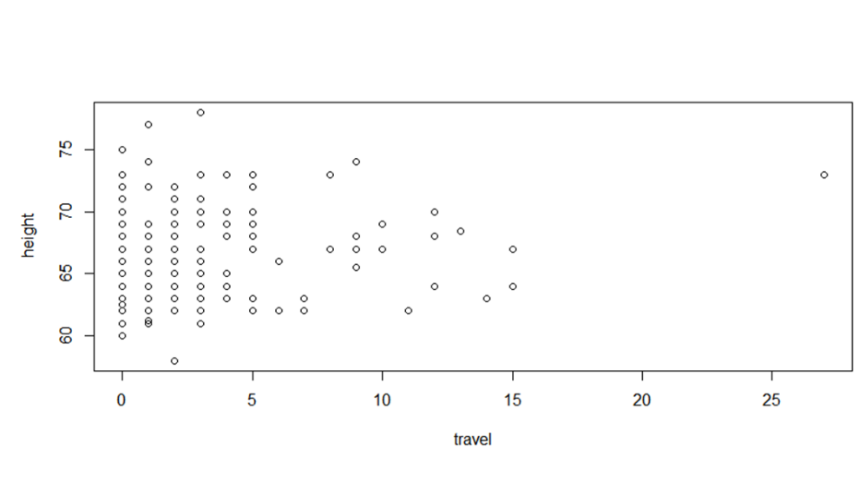
6/ Report the correlation between number of countries visited and height here (as always, to 2 decimal places). 0.14(with margin: 0
7/ Did you need to account for missing data in order to calculate this correlation? If so, what did you do?
Yes, pairwise deletion ("use = "pairwise.complete.obs") is a better choice.
8/ What is the internal consistency reliability of the conscientiousness scale? (Report to 2 decimal places).
0.82 (with margin: 0)
9/ Is this an acceptable level of reliability? How do you know?
Yes it is, because it is greater than 0.7
10/ What is the mean level of conscientiousness, overall, in our sample? Note that I am not asking you to find the mean conscientiousness level by year or any other grouping variable - this is the overall mean for all members of the class.
3.69 (with margin: 0)
11/ Find the correlations among the overall conscientiousness score, the item about childhood neatness, and number of countries visited. Report the values of all of those correlations here.
- Conscientiousness & neatness: 0.52
- Conscientiousness & number of countries visited: -0.20
- Neatness & number of countries visited: -0.05
12/ Find scatterplots of those correlations and upload them here (remember that you should be able to get all of the correlations from one line of script – no need to plot each correlation separately).
